**INFORMATION SYSTEM**

An [information system](javascript:winnew1()) is a set of interrelated components that collect or retrieve, process, store, and distribute information to support decision making and control in an organization. Information systems can also be used to analyze problems, visualize complex subjects, and create new products.  
[Information](javascript:winnew2()) is [data](javascript:winnew3()), or raw facts, shaped into useful form for humans.

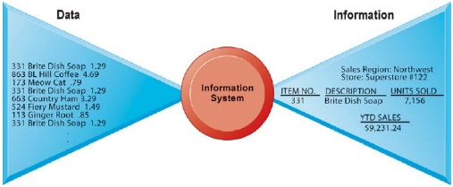

**Fig: DATA AND INFORMATION**  
Raw data from a supermarket checkout counter can be processed and organized to produce meaningful information, such as the total unit sales of dish detergent or the total sales revenue from dish detergent for a specific store or sales territory.

|  |
| --- |
| [Input](javascript:winnew4()), [processing](javascript:winnew5()), and [output](javascript:winnew6()) are the three activities in an information system that produce the information an organization needs. Input captures or collects raw data from within the organization or from its external environment. Processing converts this raw input into a meaningful form. Output transfers the processed information to the people who will use it or to the activities for which it will be used. Information systems also require [feedback](javascript:winnew7()), which is output that is returned to appropriate members of the organization to help them evaluate or correct the input stage. |
| **Fig: FUNCTIONS OF AN INFORMATION SYSTEM** An information system contains information about an organization and its surrounding environment. Three basic activities—input, processing, and output—produce the information organizations need. Feedback is output returned to appropriate people or activities in the organization to evaluate and refine the input. Environmental actors, such as customers, suppliers, competitors, stockholders, and regulatory agencies, interact with the organization and its information systems.  **DIMENSIONS OF INFORMATION SYSTEMS**  An information system represents a combination of management, organization, and technology elements. The management dimension of information systems involves leadership, strategy, and management behavior. The technology dimensions consist of computer hardware, software, data management technology, and networking/telecommunications technology (including the Internet). The organization dimension of information systems involves the organization‘s hierarchy, functional specialties, business processes, culture, and political interest groups.    FIG: INFORMATION SYSTEMS ARE MORE THAN COMPUTERS Using information systems effectively requires an understanding of the organization, management, and information technology shaping the systems. An information system creates value for the firm as an organizational and management solution to challenges posed by the environment |

**Organizations:**

Organizations are formal social units developed to the attainment of specific goals. The key elements of an organization are its people, structure, operating procedures, politics, culture, and functional specialties.

**People:** Organizations require many different kinds of skills and people like managers (such as senior, middle, and operational) who make decisions and plans to solve organizational problems, knowledge workers (such as engineers, architects, or scientists) who design products or services and create new knowledge, data workers (such as secretaries,

bookkeepers, or clerks) who process the organizations paperwork, and production or service workers (such as machinists, assemblers, or packers) who actually produce the organizations products or

**Structure:** Organizations coordinate work through a structured The hierarchy arranges people in a pyramid structure of rising authority and responsibility. The upper levels of

hierarchy consist of managerial, professional, and technical employees, whereas the lower

levels consist of operational personnel.

**Standard Operating Procedures (SOPs):** Standard operating procedures (SOPs) are formal rules that have been developed over a long time for achieving organizational Firm‘s business processes are based on its SOPs.

**Organizational Politics:** People in organization occupy different positions with different specialties, concerns and perspectives. As a result, they naturally have divergent and differing viewpoints about how Resources, Rewards, and Punishments should be distributed. This will result in political struggle for resources, competition and conflict within

Every Organizational.

**Culture:** It is a set of fundamental assumptions about what products the organization should produce, how it should produce them, where, and for whom. Organizational culture is a powerful restraint on change, especially technology change. Any technological change that threatens commonly held cultural assumptions usually meets a great deal of resistance.

**Business Functions:** The major business functions, or specialized tasks performed by business organizations include sales and marketing (selling the organization‘s products and services), manufacturing and production (producing products and services), finance (managing the organization‘s financial assets like cash, stocks, ), accounting (maintaining the organization‘s financial assets and accounting the flow of funds), and human resources (attracting, developing, and maintaining the organization‘s labor force; maintaining employee records).

**Management:**

Management‘s job is to make decisions and formulate action plans to solve organizational problems. Managerial roles and decisions vary at different levels of the organization. Senior managers occupy the topmost hierarchy and are responsible for making long-range decisions. Middle managers occupy in the middle of the organizational hierarchy who are responsible for carrying out the plans and goals of senior management. Operational managers monitor the day-to-day activities of the organization. Managers play an important role in organizations. We can understand managerial functions by examining classical and contemporary models of managerial behavior.

**Classical Models of Management**: The classical descriptions of management focuses on five classical functions of managers like planning, organizing, leading, and controlling. These terms actually describe formal managerial functions and are unsatisfactory as a description of what managers actually do in their jobs. For example, these terms do not address what managers actually do when they plan, decide things, and control the work of others.

**Behavioral Models of Management:** These models describe management based on what managers actually do in their Managers‘ day-to-day behavior can be classified into 10 managerial roles. Managerial roles are expectations of activities that managers should perform in an organization. These roles fall into three categories: interpersonal, informational, and decisional.

**Interpersonal Roles:** Interpersonal management roles are grouped into three roles involving working with other Managers act as figureheads, leaders, and liaisons.

**Informational Roles:** Informational management roles are divided into three different communication-based Managers act as nerve centers, disseminators, and spokespersons.

**Decisional Roles:** Decisional management roles are sorted into four action-based roles for making and implementing Managers act as entrepreneurs, disturbance handlers, resource allocators, and negotiators.

**Information Technology:**

Information technology is the tool used by managers to deal with change. The technology dimension consists of computer hardware, software, data management technology, and networking/telecommunications technology

**Computer Hardware:** It is the physical equipment used for input, processing, and output activities in an information system. It consists of processing unit; various input, output, and storage devices; and physical media to link these devices

**Computer Software:** It consists of detailed pre programmed instructions that control and coordinate the work of computer hardware components in an information.

**Data Management Technology:** In order to keep track of all of the information stored, we need data management software that is designed to organize the information so that we can readily retrieve what we are looking for.

**Communication technology:** It includes physical devices and software that link various computer hardware components that transfer data from one physical location to another. This technology helps to connect computers and communication equipment’s for sharing voice, data, images, sound, or video in networks. A network links two or more computers to share data. All the above technologies collectively form the firm‘s information technology (IT) infrastructure. The IT infrastructure provides the foundation or platform on which the firm can build its specific information systems. So, each organization must carefully design and manage its IT infrastructure according to the needs of the information system.

**Types of Information System:**

Information Systems are classified by organisational levels, mode of data, processing, system objectives and type of support provided.

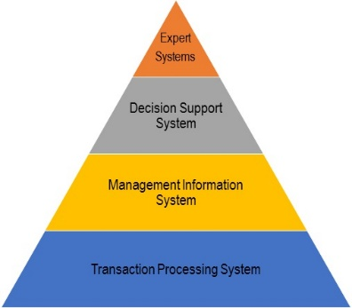

Following are the TYPE of information system:

**1. Transaction Processing System (TPS):**

* Transaction Processing System are information system that processes data resulting from the occurrences of business transactions
* Their objectives are to provide transaction in order to update records and generate reports i.e to perform store keeping function
* The transaction is performed in two ways: **Batching processing** and **Online transaction processing**.
* **Example:** Bill system, payroll system, Stock control system.

**2. Management Information System (MIS):**

* Management Information System is designed to take relatively raw data available through a Transaction Processing System and convert them into a summarized and aggregated form for the manager, usually in a report format. It reports tending to be used by middle management and operational supervisors.
* Many different types of report are produced in MIS. Some of the reports are a summary report, on-demand report, ad-hoc reports and an exception report.
* **Example:** Sales management systems, Human resource management system.

**3. Decision Support System (DSS):**

* Decision Support System is an interactive information system that provides information, models and data manipulation tools to help in making the decision in a semi-structured and unstructured situation.
* Decision Support System comprises tools and techniques to help in gathering relevant information and analyze the options and alternatives, the end user is more involved in creating DSS than an MIS.
* **Example:** Financial planning systems, Bank loan management systems.

**4. Experts System:**

* Experts systems include expertise in order to aid managers in diagnosing problems or in problem-solving. These systems are based on the principles of artificial intelligence research.
* Experts Systems is a knowledge-based information system. It uses its knowledge about a specify are to act as an expert consultant to users.
* Knowledgebase and software modules are the components of an expert system. These modules perform inference on the knowledge and offer answers to a user’s question

**Business Process Re-engineering**

According to **Dr. Michael Hammer**,

*“Business Process Re-engineering is the fundamental rethinking and radical design of business processes to achieve dramatic improvements in critical, contemporary measures of performance such as cost, quality, service and speed.”*

**Business process re-engineering** is not just a change, but actually it is a dramatic change and dramatic improvements. This is only achieved through overhaul the organization structures, job descriptions, performance management, training and the most importantly, the use of IT i.e. Information Technology.

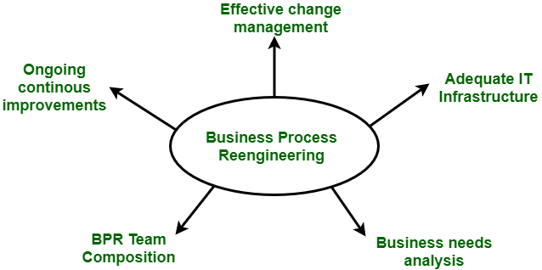

***Figure :****Business Process Re-engineering*

BPR projects have failed sometimes to meet high expectations. Many unsuccessful BPR attempts are due to the confusion surrounding BPR and how it should be performed. It becomes the process of trial and error.

**Phases of BPR :**  
According to Peter F. Drucker, ” Re-engineering is new, and it has to be done.” There are 7 different phases for BPR. All the projects for BPR begin with the most critical requirement i.e. communication throughout the organization.

1. Begin organizational change.
2. Build the re-engineering organization.
3. Identify BPR opportunities.
4. Understand the existing process.
5. Reengineer the process
6. Blueprint the new business system.
7. Perform the transformation.

**Objectives of BPR :**  
Following are the objectives of the BPR :

1. To dramatically reduce cost.
2. To reduce time requirements.
3. To improve customer services dramatically.
4. To reinvent the basic rules of the business e.g. The airline industry.
5. Customer satisfaction.
6. Organizational learning.

**Challenges faced by BPR process :**  
All the BPR processes are not as successful as described. The companies that have start the use of BPR projects face many of the following challenges :

1. Resistance
2. Tradition
3. Time requirements
4. Cost
5. Job losses

**Advantages of BPR :**  
Following are the advantages of BPR :

1. BPR offers tight integration among different modules.
2. It offers same views for the business i.e. same database, consistent reporting and analysis.
3. It offers process orientation facility i.e. streamline processes.
4. It offers rich functionality like templates and reference models.
5. It is flexible.
6. It is scalable.
7. It is expandable.

**Disadvantages of BPR :**  
Following are the Disadvantages of BPR :

1. It depends on various factors like size and availability of resources. So, it will not fit for every business.
2. It is not capable of providing an immediate resolution.